20th May 2019

**Björk lands double in FIA WTCR in Zandvoort, The Netherlands**

The Swede enjoyed a good weekend at Zandvoort striking twice for Cyan Racing Lynk & Co, while Ehrlacher took 2nd in Race 3. Meanwhile after Guerrieri’s win in Race 2 he keeps the lead of the FIA World Touring Car Cup series. Over 100,000 fans watched the splendid racing with FIA President Jean Todt and Red Bull Racing drivers Gasly and Verstappen in attendance too.

During rounds 10, 11 and 12 of the FIA WTCR with Japanese premium tyre manufacturer YOKOHAMA as official tyre supplier, Thed Björk scored his second victory of the WTCR Race of Netherlands weekend as discussions over team orders became a talking point during Race 3. Björk was the fastest from the line but Pole Position driver Yann Ehrlacher, in another Chinese-developed Lynk & Co 03 TCR, moved to the right to block and made contact with his team-mate, who still accelerated into the lead. As they started lap three, the order on the team radio was to “swap positions on the main straight”, and Björk obliged over fears Ehrlacher would be penalised for his attempts to hold onto first place at the start – and to honour a pre-race agreement for the starting order to be maintained. Ehrlacher then led until lap six when it was clear he would not be penalised beyond receiving a driving standards flag and the decision was taken to order Björk back through to the front, a position he held to the flag for his third win of 2019. Young Frenchman Ehrlacher responded emotionally over team radio in his bid to stay in front, but eventually gave up on what would have been his first victory in 2019 and let Björk back through on lap 11 to claim a third win of 2019.

Behind the Lynk & Co-powered pair, Augusto Farfus looked set for his first podium finish in the WTCR – only for fellow BRC Hyundai driver and title contender Norbert Michelisz to pass him on the last lap after the order was given to help Michelisz's stronger title prospects. Yvan Muller, who became involved in Cyan’s team order discussions via the radio during the race, finished where he started in 5th having lost his Pole Position for non-compliance regarding the maximum boost pressure and the maximum engine speed values as published in the Balance of Performance chart issued for the event. PWR Racing’s Mikel Azcona completed a strong weekend with more points in sixth, ahead of Race 2 podium finisher Johan Kristoffersson of SLR Volkswagen. Race 2 winner Esteban Guerrieri was 8th for ALL-INKL.COM Münnich Motorsport, with BRC’s Gabriele Tarquini and SLR’s Rob Huff completing the top 10.

Earlier in the weekend, Muller and Azcona completed the Race 1 podium with SLR Volkswagen team-mates Benjamin Leuchter and Johan Kristoffersson doing likewise in Race 2. It was the first podium for the Sébastien Loeb Racing-run duo following a tough run of results. Guerrieri will travel to Germany – his ALL-INKL.COM Münnich Motorsport team’s home event – 11 points in front in the title chase with Björk up to second. Erstwhile title pacesetter, Néstor Girolami endured a challenging weekend and slips to third after taking a best finish of P10 in Race 2.

The series continues at the Legendary Nürburgring with the Race of Germany on 20-22nd June.

**Current Driver standings**;

Esteban Guerrieri 161

Thed Björk 150

Nestor Girolami 135

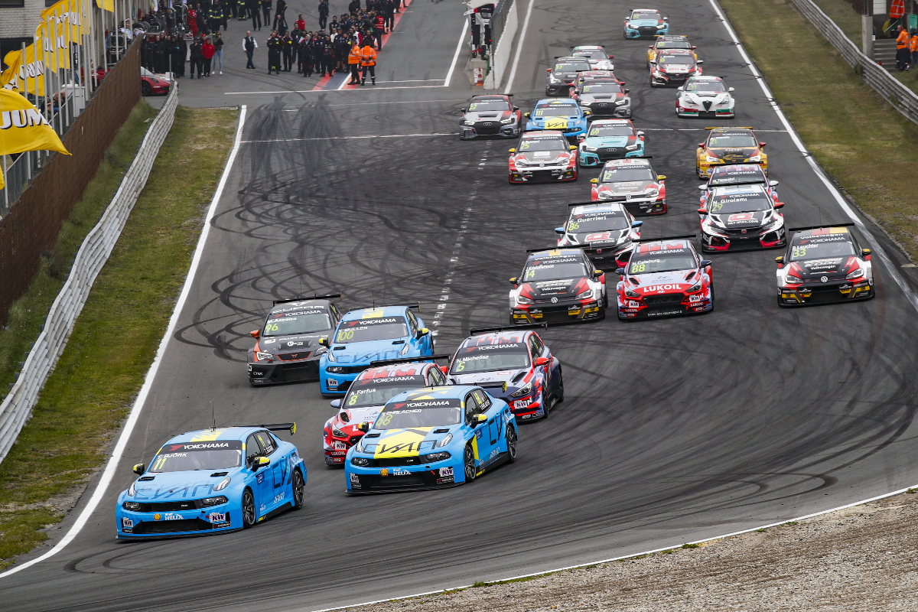

*Race-3-start photo Florent Gooden (1)*

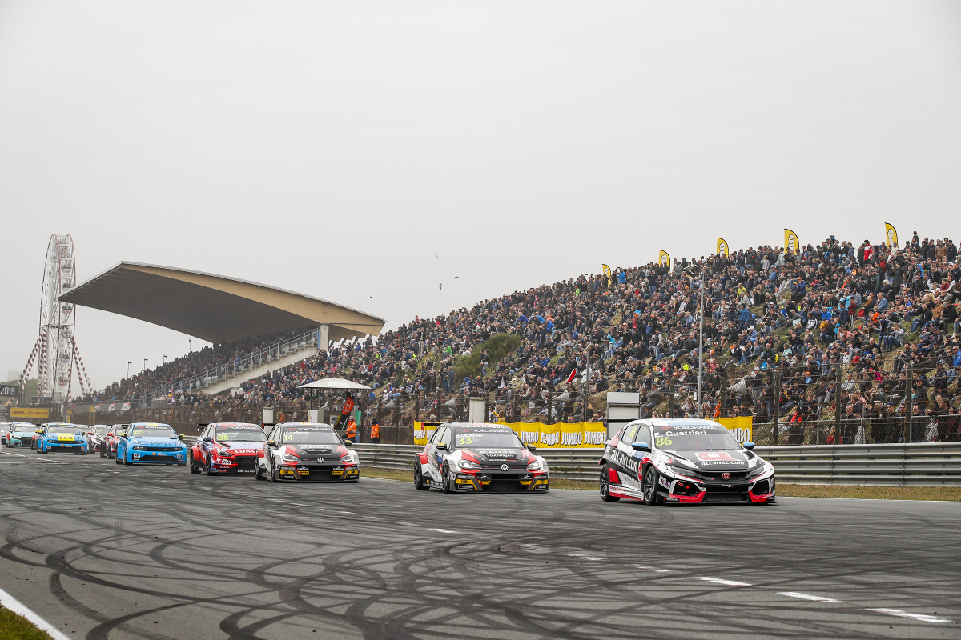

*Race-3-start photo Florent Gooden (2)*